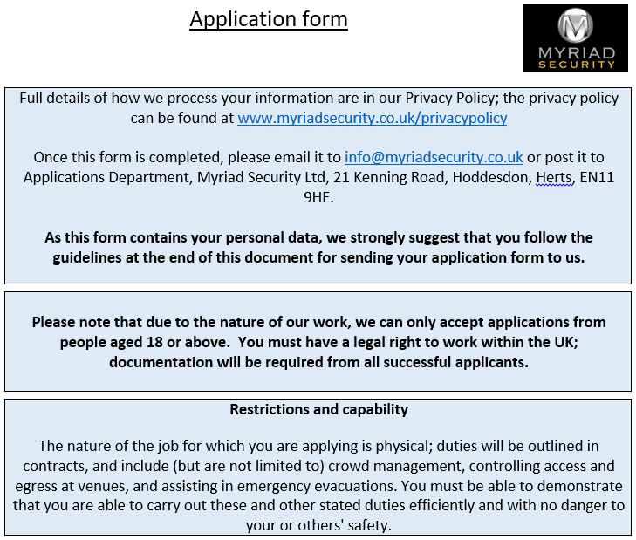
Full name
Address (including postcode)
Telephone number
Email address

Work/education history
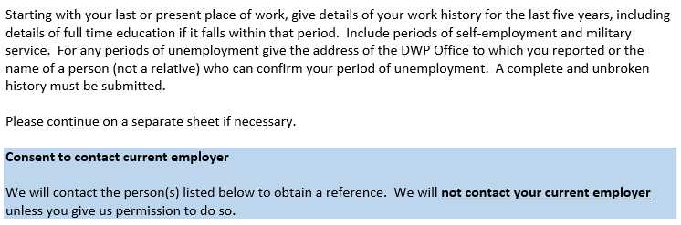
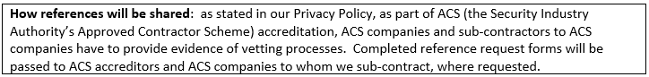

I give consent for Myriad Security Ltd to contact my current employer to obtain a reference.
Signed
Date

Current employer
Name and address of employer/DWP office/Job Centre/place of education | Start Date | Finish Date | Position held | Company contact email address
Reason for leaving

Supporting statement: reference requests

I give consent for Myriad Security Ltd to contact previous employers and named referees to obtain either employer or character references.
Signed
Name
Date

Name and address of employer/DWP office/Job Centre/place of education | Start Date | Finish Date | Position held | Company contact email address
Reason for leaving

Name and address of employer/DWP office/Job Centre/place of education | Start Date | Finish Date | Position held | Company contact email address
Reason for leaving

Name and address of employer/DWP office/Job Centre/place of education | Start Date | Finish Date | Position held | Company contact email address
Reason for leaving

Name and address of employer/DWP office/Job Centre/place of education | Start Date | Finish Date | Position held | Company contact email address
Reason for leaving

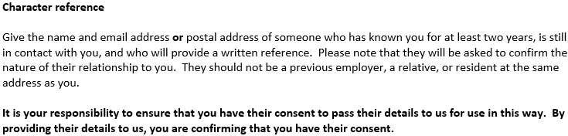

Name | Email address | Address
 | Please provide either an email or postal address (not both)

Training or relevant qualifications

If you have had relevant training or are qualified in any of the following, please give details below:

Health and Safety
Security (not SIA)
Fire Fighting
First Aid
SIA training – please complete if you have an SIA licence/SIA licences:
Licence type: |  |  | Expiry date:
Licence number:
Licence type: |  |  | Expiry date:
Licence number:
Licence type: |  |  | Expiry date:
Licence number:

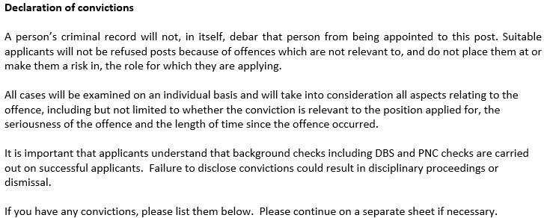

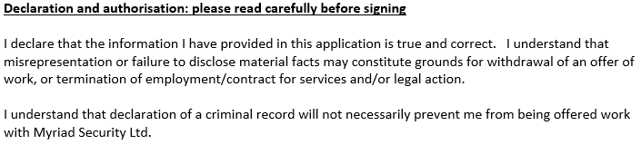
Name
Signature
Date



